Linux lab exercise

Name: J S Nivas Nirmal
Reg:17MIS1146

Script 1
1.Install the sl.

Command:
sudo apt install sl
To check the version:
sl -v
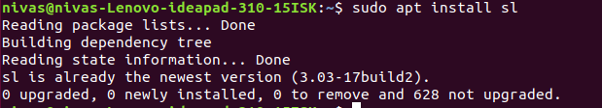

Script 2
- using reverse function.

Command:
rev
output:
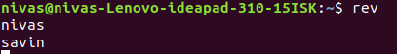

- using factor:
